**POV QUESTION**

What can we design that will give people of AP more safety on roads?

1. Driverless vehicles

2. Flying cars

3. Vehicle starts by detecting alcohol percent in driver

4. Lighting up of the roads

5. More flyovers for less traffic

6. Navigation traffic sensoring

7. Awareness on traffic rules

8. Traffic warning boards by using sensors

9. App based on traffic control in surroundings

10. Usage of safety standard vehicles

11. Speed sensors on roads

12. Strict laws on traffic rules violation

13. Sensored highway lights

14. Drones to keep track on traffic heavy roads

15. Sensors in vehicles that alert in case of accidents

16. AI based traffic lights

**Random Prompts**

**Think of a solution that begins with the letter D?**

* Drones to keep track on traffic heavy roads
* Driverless vehicles

**What solution do you think of when you read the word “Accidents”?**

* Sensors in vehicles that alert in case of accidents
* Vehicle starts by detecting alcohol percent in driver

**Counterfactuals (Imaginary World)**

* Flying cars
* Holography concept at zebra crossing

**Worst Ideas**

* Uneven roads

Flat roads

* Decreasing traffic Signals

Increasing traffic signals

**Journey to the Future**

* Robots for traffic control
* Driverless cars
* Flying cars

**Perspective shifting**

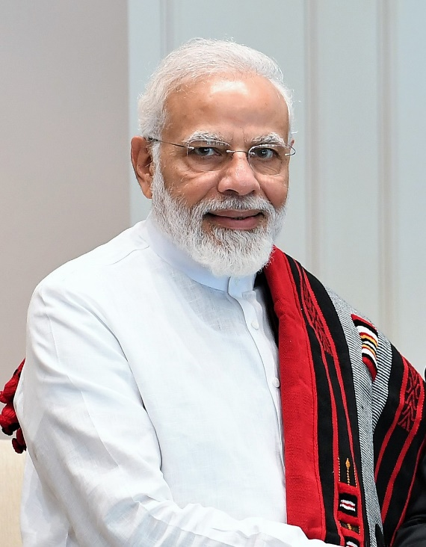

* Increasing lanes on the highways
* Increasing fly Overs
* Strict laws on traffic rules violation



* Highlighting accident prone areas in Google Maps.
* Google assistant (or Siri) that warns when speed limit increases while driving